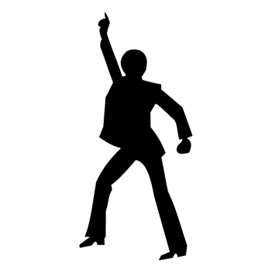
Ooooohhh Oooohhhhh
(Chorus 1)
I'll go (a – ha- ha) where your music takes me (a – ha- ha)
Where your rhythm makes me (a – ha- ha)
That's where my destiny - is gonna be
And I'll be (a – ha- ha) your second harmony
We'll make sweet melodies (a – ha- ha)
Ever so tenderly 'cause we got the key (yeah)
Everybody's searching for a dream - People making plans
Well I've got what I've been searching for -
Right in the palm of my hand
Well I want you to know - That I won't let you go
(Repeat chorus 1)
(Chorus 2)
People all over the world - Join hands
Start a love train - love train
People all over the world - Join hands
Start a love train, - love train
The next stop that we make – will be England
Tell all the folks in Egypt and Israel too
Don’t you know that it’s time – to get on board
And let this train keep on riding – riding on through
(Repeat chorus 2)
Ride, let it ride
Let it ride - Let it ride - Let it ride

(Chorus 3)
Don't take away - the music
It's the only thing I've got - It's my piece of the rock
Don't take away - the music
Everything else is gone - Don't strip my world of its song
Don't take my music ooh ooh ooh ( X4)
Woah, oh, oh, oh, oh, oh, oh, oh, - aahhh, aahhh, (key change)
Woah, oh, oh, oh, oh, oh, oh, oh, - aahhh, aahhh,
(Repeat chorus 3)
Don't take away - the music

