(ALL ) Oooh oooh oooh oooh
(M) I may not always love you - But long as there are stars above you
(L & H) Oooh ………………
(M) You’ll never need to doubt it - I'll make you so sure about it
(L & H) Oooh ………………
(ALL ) God only knows what I'd be without you
(M) If you should ever leave me - Though life would still go on, believe me
(L & H) Oooh ………………
(M) The world could show nothing to me - So what good would living do me?
(L & H) Oooh ………………
(ALL ) God only knows what I'd be without you
God only knows what I'd be without you
(M) Ooooh ……………
(H) Badada Badada…… Bada dada da
Badada Badada…… Bada dada da
(L) Badada Badada…… Bada dada dada da
Badada Badada…… Bada dada dada da
Badada Badada…… Bada dada dada da
(ALL) God only knows what I'd be without you

(H & L) Please don’t leave me
(M) If you should ever leave me - Though life would still go on, believe me
(H & L) Be – lieve me Oh… Be – lieve me Oh…
(M) The world could show nothing to me - So what good would living do me?
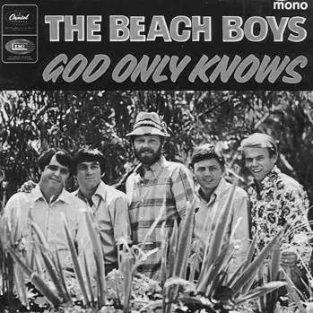
(ALL) God only knows what I'd be without you
God only knows what I'd be without you
(H) Badada Badada…… Bada dada da
(M) Ooooh … Ooooh ….
(L) God only knows what I'd be without you
(ALL) God only knows what I'd be without
You …………

